ML Unit-3 Notes:
CLUSTERING AND DIMENSIONALITY REDUCTION
Topics to cover
- Unsupervised learning: K-means, Instance Based Learning
- KNN, Gaussian mixture models and Expectation maximization.
- Dimensionality Reduction
- Principal Component Analysis (PCA)
- Linear Discriminant Analysis (LDA)
- Latent Variable Models (LVM)
- Latent Dirichlet Allocation (LDA)
- Independent Component Analysis (ICA)

Unsupervised learning: K-means, Instance Based Learning:

Clustering:
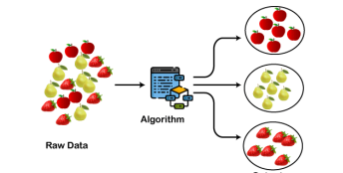
ADVANCED TAXONOMY OF CLUSTER ANALYSIS AND ALGORITHMIC ARCHITECTURE
Clustering is an unsupervised learning process that automatically groups unlabeled data so that objects in the same group are highly similar while objects in different groups are highly dissimilar.
- Cluster: A collection of data objects that belong to the same class because they share a common trait.
- Unsupervised Learning: The process of discovering the natural structure or grouping in a dataset without the need for prior training or labels.
- Intra-class Similarity: A quality metric where the variation between data points within a single cluster is minimized.
- Inter-class Similarity: A quality metric where the separation between different clusters is maximized.
- Distance-Based Clustering: A method where membership is determined by the geometrical closeness of objects.
- Euclidean Metric: The standard mathematical measure used to calculate the distance $D$ between two points p and q, defined by the formula
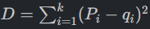
DESIRABLE PROPERTIES OF A CLUSTERING ALGORITHM
- Scalability: The algorithm must remain efficient in terms of time and space as the volume of data increases.
- Data Type Versatility: The ability to process and group different types of data effectively.
- Minimal Domain Knowledge: The system should require very few input parameters from the user to function.
- Interpretability: The final clusters must be usable and provide meaningful insights into the data structure.
- In this case we easily identify the 4 clusters into which the data can be divided; the similarity criterion is distance : two or more objects belong to the same cluster if they are “close” according to a given distance (in this case geometrical distance ) This is called distance –based clustering.
CLUSTER CENTROID LOGIC AND ARCHITECTURE
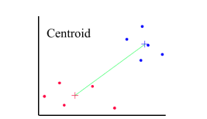
- Centroid Definition: The centroid is a central point in a cluster where its parameter values are the means of the values of every point assigned to that cluster.
- Membership Determination: Algorithms evaluate the distance between individual data points and these centroids to decide which group a point belongs to.
- Functional Sequence:
  - Initialize the process by selecting or calculating central points for potential groups.
  - Calculate the distance between each raw data point and the available centroids using the Euclidean metric.
  - Assign each data point to the cluster with the closest centroid.
  - Update the centroid by calculating the new mean of all points currently assigned to the group.
  - Repeat until the centroids stabilize and no further reassignments occur.
  - Output a statistical description of the centroids and the number of components in each resulting cluster.
CLUSTERING TECHNIQUES TYPES
- Partitioning Methods: These divide a dataset into a pre-defined number of distinct, non-overlapping groups.
- Hierarchical Methods: These create a tree-like structure of nested clusters.
- Density-Based Methods: These group points based on the spatial density of data, allowing for discovery of arbitrary shapes.
- Exclusive Clustering: A rigid method where every data point is assigned to exactly one specific cluster.
- Overlapping Clustering: A flexible method where a single data point may have membership in multiple clusters.
- Probabilistic/Model-Based Clustering: Methods like Gaussian Mixture Models where each point has a probability of belonging to various clusters based on statistical distributions.
THE "TRAP" LIST
- The Best Criterion Myth: There is no absolute "best" clustering method; the quality of the output depends entirely on the user's specific goals and the similarity measures selected.
- Centroid Misidentification: A centroid is a mathematical average (mean) of cluster members and is not necessarily a point that existed in the original dataset.
- Overlapping Failure: Exclusive algorithms like K-means will fail to represent data accurately if the natural groups are soft or overlapping.
CONCENTRATED SUMMARY
Clustering is an unsupervised technique used to partition large datasets into meaningful subclasses by maximizing intra-class similarity and minimizing inter-class similarity. High-quality algorithms must be scalable, interpretable, and capable of handling diverse data types with minimal user intervention. The core functional unit is the cluster centroid—the mean of all points in a group—which uses distance metrics like the Euclidean formula to determine group membership. Major techniques include partitioning, hierarchical, and density-based methods, which can be implemented as exclusive, overlapping, or probabilistic models depending on the data structure.

K-Means Clustering:
K-MEANS CLUSTERING ARCHITECTURE AND OPTIMIZATION STRATEGY
K-means clustering is a method that sorts a messy pile of unlabeled data into a specific number of groups by making sure every point is as close as possible to a central "home base" called a centroid,.
- Unsupervised Learning: K-means is an unsupervised algorithm, meaning it discovers patterns in data without any prior training or pre-defined labels,.
- The "K" Factor: The variable $K$ defines the exact number of non-overlapping clusters the algorithm will create.
- Centroid-Based Logic: Each cluster is defined by a central point (centroid), and the algorithm's primary goal is to minimize the total distance between data points and these centroids.
- Iterative Process: The algorithm repeats its calculations over and over until it finds the best possible grouping for the data.
- Data Membership: In this model, every data point is assigned to exactly one cluster based on shared properties and proximity.
ALGORITHM AND STEP-BY-STEP ARCHITECTURE
- Task 1 (Center Identification): The algorithm uses an iterative process to find the best physical coordinates for $K$ center points.
- Task 2 (Point Assignment): The algorithm assigns every individual data point to its nearest center to form distinct groups.
- Functional Sequence:
  - Initialization: Decide on the number of clusters K.
  - Random Selection: Choose K random points to serve as the initial centroids; these points do not need to be part of the actual dataset,.
  - Initial Grouping: Calculate the distance from every data point to these K centroids and assign each point to the closest one,.
  - Centroid Update: Look at all the points in a cluster, find their average (center of gravity), and move the centroid to this new location,,.
  - Reassignment Loop: Re-calculate the distance of every point to the updated centroids and move any point that is now closer to a different center,.
  - Convergence: Repeat the update and reassignment steps until no more points change groups and the centroids stop moving,.

Steps:
Step-1: Select the number K to decide the number of clusters.
Step-2: Select random K points or centroids. (It can be other from the input dataset).
Step-3: Assign each data point to their closest centroid, which will form the predefined K clusters.
Step-4: Calculate the variance and place a new centroid of each cluster.
Step-5: Repeat the third steps, which means reassign each datapoint to the new closest centroid of each cluster.
Step-6: If any reassignment occurs, then go to step-4 else go to FINISH.
Step-7: The model is ready.
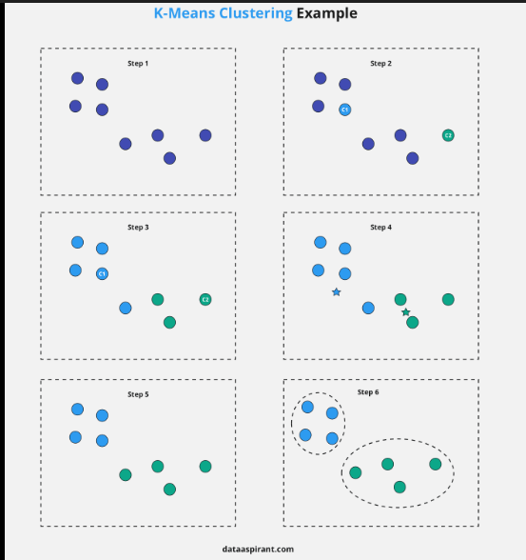

THE ELBOW METHOD AND OPTIMAL "K" SELECTION
- Selection Challenge: The performance of the model depends on choosing the right K, but there is no automatic way for the algorithm to know the best number on its own.
- WCSS (Within Cluster Sum of Squares): This is the mathematical metric used to measure how "compact" or "tight" the clusters are.
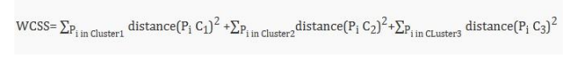
- WCSS Calculation: It is the sum of the squared distances between every point in a cluster and that cluster's centroid.
- The Elbow Workflow:
  - Run the K-means algorithm multiple times using different values for K, usually ranging from 1 to 10.
  - Calculate the WCSS for every single $K$ value tested.
  - Plot the results on a graph where the x-axis is $K$ and the y-axis is the WCSS.
  - Identify the "elbow" point, which is the sharp bend in the curve where the WCSS stops dropping rapidly,.
  - Selection: The K value at this "elbow" is the optimal balance between cluster count and data accuracy,.
THE "TRAP" LIST
- The Randomness Trap: Because the algorithm starts with random centroids, different starting positions can lead to different final clusters,.
- Hard Membership: K-means is an "exclusive" clustering method, meaning a point cannot belong to two clusters even if it sits exactly in the middle,.
- The Fixed K Requirement: Unlike other methods, you must define $K$ before you start; the algorithm cannot "discover" that it needs more or fewer groups while running.
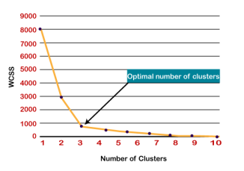
CONCENTRATED SUMMARY
K-means is a centroid-based unsupervised algorithm that partitions unlabeled data into $K$ distinct clusters by minimizing the sum of distances between points and their group centers,. The process is highly iterative, involving the initialization of random centroids, point assignment based on proximity, and the continuous updating of centroids based on the mean of the cluster members until convergence is reached,. To ensure the model is effective, users employ the Elbow Method, which identifies the optimal $K$ value by finding the point where increasing the number of clusters no longer significantly reduces internal variation (WCSS),.

K-NN
K-NEAREST NEIGHBOR (KNN) INSTANCE-BASED LEARNING TAXONOMY
K-Nearest Neighbor is a supervised machine learning algorithm that classifies new data points by placing them into the category most similar to existing available instances based on proximity.
- Supervised Learning: The algorithm operates under a supervised approach, requiring a labeled training set where data points are already assigned to specific classes,.
- Non-Parametric: It makes no assumptions regarding the underlying distribution or structure of the data.
- Lazy Learner: It does not perform calculations or learn from the training set immediately; instead, it stores the dataset and only executes classification actions when a new data point is introduced,,.
- Similarity Principle: The algorithm assumes that similar data points exist in close proximity and uses the similarity degree between new data and available cases to determine membership,,.
- Multipurpose Functionality: While primarily used for classification problems, KNN can also be applied to regression tasks,.
- K-Value: A user-defined parameter representing the specific number of neighboring data points the algorithm evaluates to make a classification decision,.
- Euclidean Distance: The mathematical metric used to calculate the gap between points, formulated as the square root of $(x_2-x_1)^2 + (y_2-y_1)^2$,,.
STEP-BY-STEP ARCHITECTURE (HOW KNN WORKS)
- Step 1: Select the value of $K$, which defines the number of neighboring data points to be consulted,.
- Step 2: Calculate the Euclidean distance between the new data point and every existing point in the training dataset,.
- Step 3: Identify and select the $K$ points that are geographically closest (have the smallest distance) to the new data point,.
- Step 4: Conduct a tally (count) of how many of these $K$ neighbors belong to each existing category,.
- Step 5: Assign the new data point to the category that received the highest number of neighbors (the maximum count),.
- Step 6: The classification is complete and the model is ready.
REQUIREMENT LOGIC (WHY WE NEED KNN)
- Categorical Resolution: KNN is required when an unknown data point $x_1$ needs to be sorted into one of several existing classes, such as Category A or Category B.
- Identification by Similarity: It is essential for complex identification tasks, such as distinguishing whether an image represents a cat or a dog based on the most similar physical features found in the dataset,.
DIFFERENTIAL ANALYSIS (K-MEANS VS. KNN)
- Learning Category: K-means is an unsupervised algorithm used for clustering; KNN is a supervised algorithm used for classification.
- Processing Speed: K-means is an eager learner that builds a model immediately; KNN is a lazy learner that defers calculation until a query is made.
- Input Data: K-means requires unlabeled data to gather and group; KNN requires labeled data to classify or predict test samples.
- Functional Meaning of K: In K-means, $K$ represents the number of clusters to be formed; in KNN, $K$ is the number of nearest neighbors used to categorize a sample.
THE "TRAP" LIST
- The K-Identity Trap: Never confuse the $K$ in K-means (cluster count) with the $K$ in KNN (neighbor count), as they serve fundamentally different structural purposes.
- The Learning Delay: Users often mistake the "training phase" of KNN for active learning, but the algorithm actually does nothing but store data until a new point is provided,.
- Label Dependency: Unlike K-means, KNN will completely fail if the initial dataset is not pre-labeled, as it has no way to vote on categories without them.
CONCENTRATED SUMMARY
K-Nearest Neighbor (KNN) is a supervised, non-parametric lazy learner that classifies new data by identifying the most similar neighbors in a stored dataset through Euclidean distance metrics,,. It operates by selecting $K$ neighbors, calculating distances, and assigning the point to the category with the highest vote count,. It is functionally the opposite of K-means, which is an unsupervised eager learner that partitions unlabeled data into $K$ clusters.
I have created a tailored report for you regarding K-Nearest Neighbor (KNN) which you can review in the Artifacts section.

